**Batch: A-3 Roll No.: 16010122104**

**Experiment / assignment / tutorial No. 8**

**Grade: AA / AB / BB / BC / CC / CD /DD**

**Signature of the Staff In-charge with date**

**Experiment No.:8**

|  |
| --- |
| **TITLE: Study and configure RIP protocol using Cisco Packet tracer** |

**_____________________________________________________________________________ AIM:** To study and configure RIP protocol using Cisco Packet tracer

**_____________________________________________________________________________**

**Expected Outcome of Experiment:**

**CO:**

**_____________________________________________________________________________**

**Books/ Journals/ Websites referred:**

1. A. S. Tanenbaum, “Computer Networks”, Pearson Education, Fourth Edition
2. B. A. Forouzan, “Data Communications and Networking”, TMH, Fourth Edition

_____________________________________________________________________________

**Pre Lab/ Prior Concepts:**

IPv4 Addressing, Subnetting, Distance Vector Protocol, Router configuration Commands.

**_____________________________________________________________________________**

**New Concepts to be learned:** RIP Protocol and its configuration.

**_____________________________________________________________________________**

**RIP (Routing Information Protocol)**

RIP is a standardized Distance Vector protocol, designed for use on smaller networks. RIP was one of the first true Distance Vector routing protocols and is supported on a wide variety of systems.

RIP adheres to the following Distance Vector characteristics:

• RIP sends out periodic routing updates (every 30 seconds)

• RIP sends out the full routing table every periodic update.

• RIP uses a form of distance as its metric (in this case, hop count).

• RIP uses the Bellman-Ford Distance Vector algorithm to determine the best “path” to a particular destination

Other characteristics of RIP include:

• RIP supports IP and IPX routing.

• RIP utilizes UDP port 520

• RIP routes have an administrative distance of 120.

• RIP has a maximum hop count of 15 hops.

**RIP Versions**

RIP has two versions, Version 1 (RIPv1) and Version 2 (RIPv2).

RIPv1 (RFC 1058) is ***classful***, and thus does not include the subnet mask with its routing table updates. Because of this, RIPv1 does not support **Variable Length Subnet Masks (VLSMs)**. When using RIPv1, networks must be contiguous, and subnets of a major network must be configured with identical subnet masks. Otherwise, route table inconsistencies (or worse) will occur.

RIPv1 sends updates as broadcasts to address 255.255.255.255.

RIPv2 (RFC 2543) is ***classless***, and thus does include the subnet mask with its routing table updates. RIPv2 fully supports VLSMs, allowing discontiguous networks and varying subnet masks to exist.

Other enhancements offered by RIPv2 include:

• Routing updates are sent via multicast, using address 224.0.0.9

• Encrypted authentication can be configured between RIPv2 routers

• Route tagging is supported.

RIPv2 can interoperate with RIPv1. By default:

• RIPv1 routers will send only Version 1packets

• RIPv1 routers will receive both Version 1 and 2 updates

• RIPv2 routers will both send and receive only Version 2 updates

We can control the version of RIP a particular interface will “send” or “receive.”

Unless RIPv2 is manually specified, a Cisco will default to RIPv1 when configuring RIP.

**RIPv1 Basic Configuration**

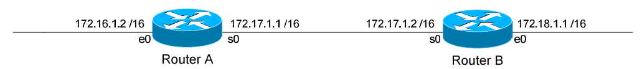

Routing protocol configuration occurs in Global Configuration mode. On Router A, to configure RIP, we would type:

**Router(config)#** router rip

**Router(config-router)#** network 172.16.0.0

**Router(config-router)#** network 172.17.0.0

The first command, router rip, enables the RIP process.

The network statements tell RIP which networks you wish to advertise to other RIP routers. We simply list the networks that are directly connected to our router. Notice that we specify the networks at their classful boundaries, and we do not specify a subnet mask.

To configure Router B:

**Router(config)#** router rip

**Router(config-router)#** network 172.17.0.0

**Router(config-router)#** network 172.18.0.0

The routing table on Router A will look like:

**RouterA#** show ip route

Gateway of last resort is not set

C 172.16.0.0 is directly connected, Ethernet0

C 172.17.0.0 is directly connected, Serial0

R 172.18.0.0 [120/1] via 172.17.1.2, 00:00:00, Serial0

The routing table on Router B will look like:

**RouterB#** show ip route

Gateway of last resort is not set

C 172.17.0.0 is directly connected, Serial0

C 172.18.0.0 is directly connected, Ethernet0

R 172.16.0.0 [120/1] via 172.17.1.1, 00:00:00, Serial0

**IMPLEMENTATION: (**printout of code)

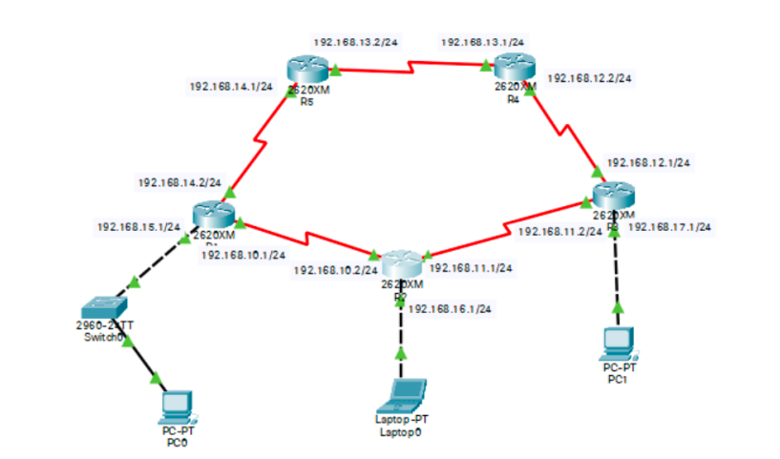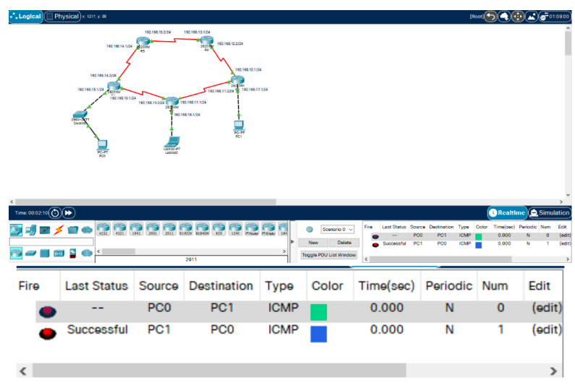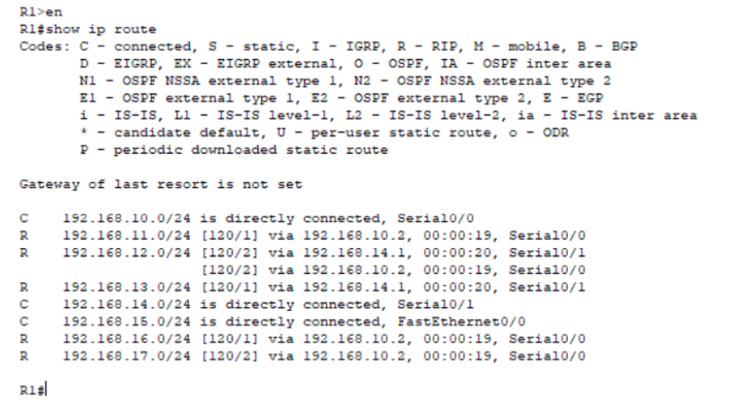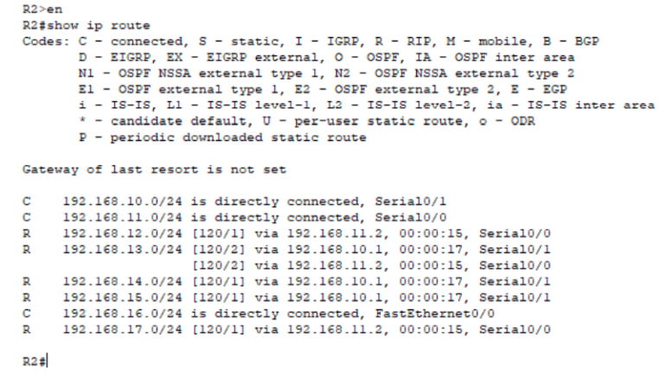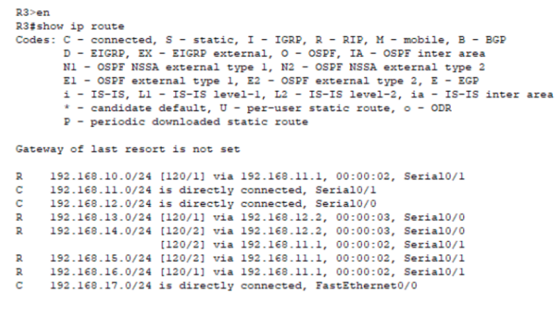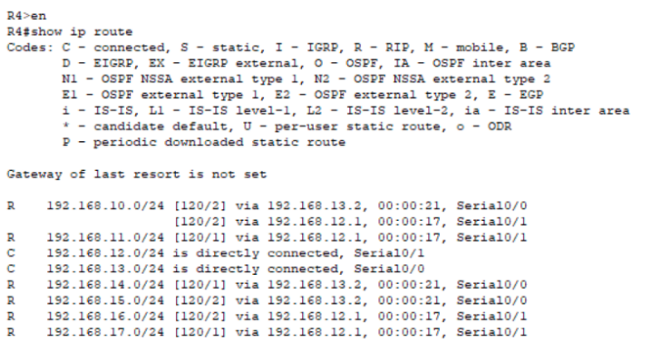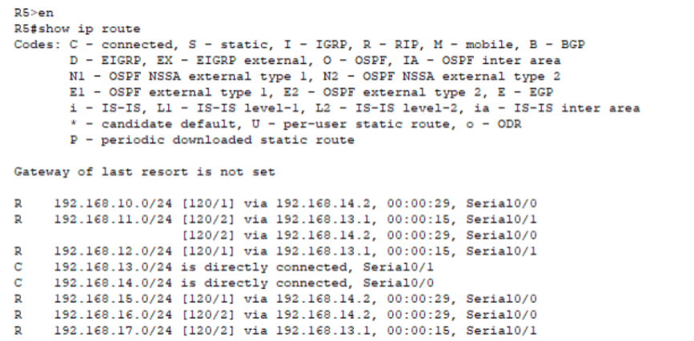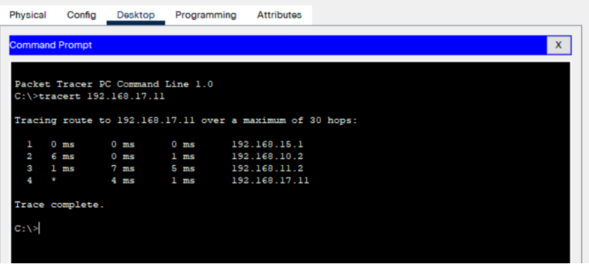

**CONCLUSION:**

**Post Lab Questions**

1. ............ are two popular examples of distance vector routing protocols.  
A. OSPF and RIP  
B. RIP and BGP  
C. BGP and OSPF  
D. BGP and SPF

2. A ......... routing table contains information entered manually.  
A. static  
B. dynamic  
C. hierarchical  
D. non static

3. A .......... routing table is updated periodically using one of the dynamic routing protocols.  
A. static  
B. dynamic  
C. hierarchical  
D. non static

4. Which of the following is not the category of dynamic routing algorithm.  
A. Distance vector protocols  
B. Link state protocols  
C. Hybrid protocols  
D. Automatic state protocols

5. In .......... forwarding, the mask and destination addresses are both 0.0.0.0 in the routing table.  
A. next-hop  
B. network-specific  
C. host-specific  
D. default

6. Differentiate between Distance Vector Routing and Link State Routing.

| **Feature** | **Distance Vector Routing** | **Link State Routing** |
| --- | --- | --- |
| **Basic Concept** | Routers share their entire routing tables with neighboring routers. Each router uses information from its neighbors to calculate its best route. | Routers build a complete topology of the network by sharing link-state information with all routers. Each router independently calculates the shortest path to every other router. |
| **Algorithm Used** | Bellman-Ford algorithm | Dijkstra’s algorithm |
| **Convergence Speed** | Slower due to iterative updates and potential for routing loops. | Faster because each router has a full map of the network and can independently compute paths. |
| **Routing Updates** | Periodic, sent to neighboring routers only | Triggered updates, sent to all routers in the network |
| **Traffic Overhead** | Lower in small networks, as updates are sent only to neighbors | Higher as each router sends updates to every router, but efficient in large networks |
| **Scalability** | Less scalable in larger networks due to potential delays and routing loops | Highly scalable as each router has a full view of the network |
| **Example Protocols** | RIP (Routing Information Protocol), IGRP | OSPF (Open Shortest Path First), IS-IS |
| **Routing Loop Prevention** | Uses techniques like split horizon, route poisoning, and hold-down timers | Typically does not suffer from routing loops due to complete network topology awareness |
| **Resource Requirements** | Lower CPU and memory requirements | Higher CPU and memory requirements |

**Date: 11/11/2024 Signature of faculty in-charge**